Tail dependence: USDCHF and USDCAD
Method 19 / daily log returns / alpha=0.05 / Alpari D1 full available history

Study setup
Logical pair: USDCHF , USDCAD
Broker symbols: USDCHF_i , USDCAD_i
Snapshot: 2026-11-03_majors_alpari_D1
Timeframe: D1
Matched return window: 1999-01-05 to 2026-11-02 (UTC bar dates)
Matched return count n: 7188
Dropped unfinished last bar dated 2026-11-03 UTC after a tick-volume check against the prior complete day.
Uniforms: ranks/(n+1); alpha=0.05
Complete matched rows (Excel): USDCHF-USDCAD_Tail_D1.xlsx
Complete matched rows (HTML table): USDCHF-USDCAD_Tail_D1_data.html

Method carried forward
Tail dependence counts how often both legs sit in an extreme uniform tail together. Matched daily log returns of close, ln(close_t / close_t-1), become u_i = rank(x_i)/(n+1) and v_i = rank(y_i)/(n+1). At alpha=0.05, lower L_hat = (# u<=alpha and v<=alpha) / (# conditioning leg <= alpha); upper uses >= 1-alpha. Both conditioning directions are reported with numerator and denominator counts. Quotes are not inverted. L_hat(0.05) is a finite-sample frequency, not the asymptotic lambda. Same-sample Pearson r is a side check. This is not causation and not a trading signal.

Results
tail | cond | L_hat | num | denom
lower | USDCAD | 0.208914 | 75 | 359
lower | USDCHF | 0.208914 | 75 | 359
upper | USDCAD | 0.214485 | 77 | 359
upper | USDCHF | 0.214485 | 77 | 359
Pearson r on returns: 0.304665

Conclusion
Over 7188 matched daily rows for USDCHF and USDCAD at alpha=0.05, lower L_hat conditioning on USDCAD is 0.2089 (75/359); conditioning on USDCHF is 0.2089. Upper L_hat conditioning on USDCAD is 0.2145; on USDCHF is 0.2145. Pearson r = 0.3047. These are finite-sample frequencies, not asymptotic lambda and not a trading signal.

Charts
Daily closes

Daily log returns

Uniforms with alpha lines
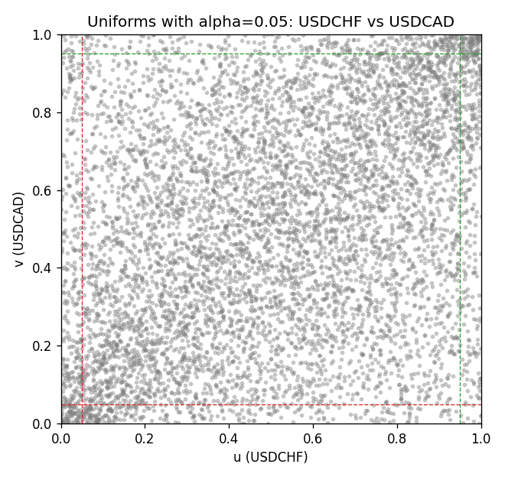

Data report
Every matched row is stored in the sibling Excel workbook named USDCHF-USDCAD_Tail_D1.xlsx, including u and v. Embedding all rows as a Word table is impractical; this file holds column summaries and the first and last 15 matched rows.
Columns: time, USDCHF_open, USDCAD_open, USDCHF_high, USDCAD_high, USDCHF_low, USDCAD_low, USDCHF_close, USDCAD_close, USDCHF_tick_volume, USDCAD_tick_volume, USDCHF_spread, USDCAD_spread, USDCHF_real_volume, USDCAD_real_volume, USDCHF_log_return, USDCAD_log_return, u, v
Column summaries (matched calculation rows)
column | count | mean | std | min | 25% | 50% | 75% | max
USDCHF_open | 7188 | 1.0975966 | 0.25229688 | 0.72022 | 0.9205375 | 0.989955 | 1.2378 | 1.8219
USDCAD_open | 7188 | 1.2667824 | 0.16892678 | 0.9168 | 1.1183975 | 1.298465 | 1.3720475 | 1.6183
USDCHF_high | 7188 | 1.1028875 | 0.2540352 | 0.73305 | 0.924845 | 0.993545 | 1.242375 | 1.8313
USDCAD_high | 7188 | 1.2716804 | 0.16888565 | 0.9336 | 1.12285 | 1.30387 | 1.37646 | 1.619
USDCHF_low | 7188 | 1.0924772 | 0.25071604 | 0.08565 | 0.91725 | 0.9863 | 1.23155 | 1.8121
USDCAD_low | 7188 | 1.2622243 | 0.16896256 | 0.9056 | 1.114065 | 1.293535 | 1.3677775 | 1.6102
USDCHF_close | 7188 | 1.0975873 | 0.25219296 | 0.72025 | 0.920805 | 0.98995 | 1.2379 | 1.8217
USDCAD_close | 7188 | 1.2667976 | 0.16890032 | 0.916 | 1.118075 | 1.29844 | 1.372365 | 1.6137
USDCHF_tick_volume | 7188 | 74305.244 | 113479.97 | 1 | 12787.25 | 40220 | 70419.75 | 858589
USDCAD_tick_volume | 7188 | 81017.898 | 147302.44 | 1 | 5560 | 40941.5 | 71627 | 1410818
USDCHF_spread | 7188 | 26.050501 | 24.7086 | 0 | 5 | 16 | 50 | 100
USDCAD_spread | 7188 | 23.4399 | 18.261108 | 0 | 9 | 17 | 40 | 60
USDCHF_real_volume | 7188 | 2.3284369e+10 | 8.9116261e+10 | 0 | 0 | 0 | 0 | 1.9331921e+12
USDCAD_real_volume | 7188 | 1.8376704e+10 | 9.6688094e+10 | 0 | 0 | 0 | 0 | 2.5751613e+12
USDCHF_log_return | 7188 | -7.133e-05 | 0.00659527 | -0.19545699 | -0.0033544 | 8.077e-05 | 0.00332477 | 0.09051364
USDCAD_log_return | 7188 | -1.556e-05 | 0.00514382 | -0.03859748 | -0.00283746 | 4.44e-05 | 0.00272629 | 0.03436319
u | 7188 | 0.5 | 0.28865505 | 0.0001391 | 0.25006955 | 0.5 | 0.74993045 | 0.9998609
v | 7188 | 0.5 | 0.28865505 | 0.0001391 | 0.25006955 | 0.5 | 0.74993045 | 0.9998609
First 15 matched rows (selected columns)
time | USDCHF_log_return | USDCAD_log_return | u | v
1999-01-05 | 0.0039424743 | -0.010131666 | 0.78341911 | 0.026846571
1999-01-06 | 0.013605652 | -0.0003306769 | 0.98372514 | 0.46473779
1999-01-07 | -0.0093883841 | 0.0015202092 | 0.058700793 | 0.65196828
1999-01-08 | 0.011040268 | -0.0020495197 | 0.96689387 | 0.30463208
1999-01-11 | 0.0052963193 | -0.0035137769 | 0.84476283 | 0.2079566
1999-01-12 | -0.0098275602 | 0.0066194721 | 0.052580331 | 0.92488524
1999-01-13 | -0.018259701 | 0.0045420214 | 0.005842259 | 0.85547364
1999-01-14 | -0.0024256692 | 0.0069376546 | 0.30504938 | 0.93197941
1999-01-15 | 0.01794228 | -0.0056905671 | 0.99485325 | 0.10738628
1999-01-18 | -0.0031856384 | 0.00098344542 | 0.25928502 | 0.59771874
1999-01-19 | -7.2518946e-05 | 0.002748513 | 0.48615941 | 0.75170399
1999-01-20 | 0.0072259871 | -0.0059646885 | 0.90777577 | 0.098901099
1999-01-21 | -0.0038232689 | -0.0042823796 | 0.22701349 | 0.16205314
1999-01-22 | -0.0001445609 | 0.0025057712 | 0.47976075 | 0.73389901
1999-01-25 | 0.0024546976 | 0.00085579808 | 0.69105578 | 0.58575602
Last 15 matched rows (selected columns)
time | USDCHF_log_return | USDCAD_log_return | u | v
2026-10-13 | -0.0024955621 | -0.0046395653 | 0.30018083 | 0.14925581
2026-10-14 | 0.0029388325 | 0.0015184751 | 0.72485742 | 0.65182918
2026-10-15 | -0.0097855323 | -0.0036101503 | 0.053554041 | 0.20211434
2026-10-16 | -0.0036230826 | -0.0034322068 | 0.23828071 | 0.21352066
2026-10-19 | 0.0036351779 | -0.0018835331 | 0.76783976 | 0.31909862
2026-10-20 | -0.0026281224 | -0.0037066008 | 0.29211295 | 0.19515927
2026-10-21 | -0.00040027413 | -0.00084691787 | 0.45611351 | 0.41452219
2026-10-22 | -0.0048036381 | -0.0026307268 | 0.18389206 | 0.26554458
2026-10-23 | 0.005652514 | 2.85545e-05 | 0.86006399 | 0.49951315
2026-10-26 | 0.0018407959 | 5.7106554e-05 | 0.6436222 | 0.50146056
2026-10-27 | 0.0026100526 | 0.0025379458 | 0.70079288 | 0.73723745
2026-10-28 | -0.0010142111 | -0.0038379274 | 0.40826262 | 0.18556127
2026-10-29 | -0.0048680164 | -0.00011436495 | 0.18083183 | 0.4849075
2026-10-30 | 0.00071594559 | -0.0010298736 | 0.5540409 | 0.3960217
2026-11-02 | -0.0071459744 | 0.00061519094 | 0.10307414 | 0.56113507

